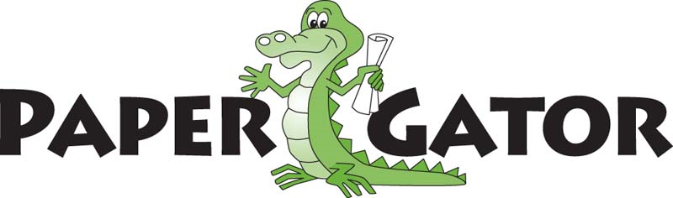

Welcome to PaperGator Recycling and Fundraising.
A successful PaperGator program starts with creating awareness and providing information. Awareness campaigns are a great way of getting people to take action and contribute. Each PaperGator host location has the opportunity to promote their program anyway they choose to help increase paper collections which in turn increases funds raised through PaperGator.
Please visit our resources page at
https://papergatorrecycling.com/resources/

Some ideas for promoting your PaperGator are listed below
- Place your PaperGator in a highly visible and accessible area
- Social Media Posts / Invitations
- Reminder posters placed near recycling/trash receptacles
- Paper Drives
- Classroom Contests
- Collection receptacles clearly labeled
- Yard Signs

Your location information will be shared on the PaperGator Recycling Facebook and Instagram pages as a new host location. If you would like to opt out of this, please notify us via email within 24 hours.
Like or Share us on - Facebook https://www.facebook.com/PaperGatorRecycling and follow us on Instagram @papergatorrecycling
Promotional Material for your PaperGator program can be found on our website under the “Resources” page. https://papergatorrecycling.com/resources/
Also, below are requirements and details of the PaperGator Program.
- Maintain a minimum requirement of one full bin per month
- Promote the program to increase your earning potential
- You are paid $.01/ pound of paper collected (based on weighted average)
- Payment is made twice per year
- NO contract or fees = NO risk or costs
- Free and regularly scheduled pick-ups for your PaperGator®

Welcome Items:
- Newspaper
- Catalogs/Magazines
- Office/school paper
- Junk Mail
- Telephone Books
- Hard/Soft cover books
- Notebooks
- Cereal Type Boxes (bag removed)
- Shredded Paper (prefer bagged in paper bags)
- 12” x 12” Cardboard

Items Not Accepted:
- Large Cardboard
- Plastic
- Metal
- Garbage

